**Q)Write a program that accepts the job_id as argument and returns a custom counter and a system counter (total records input to the map tasks) associated with that job.**

**Driver:-**

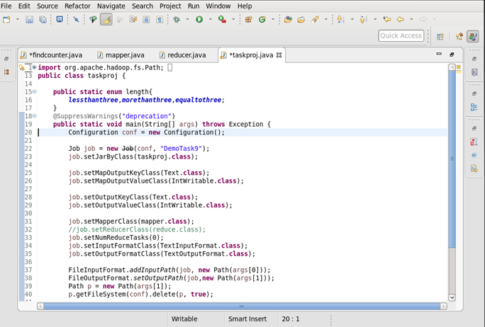

**Mapper:-**

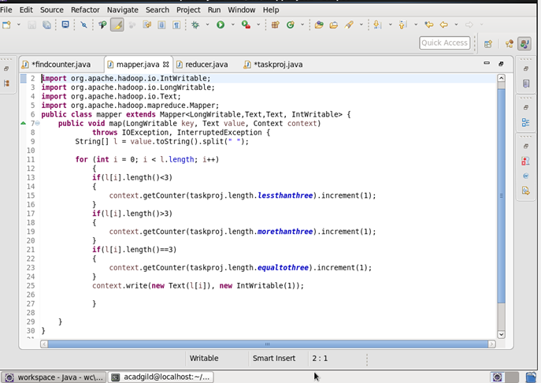

**Reducer:-**

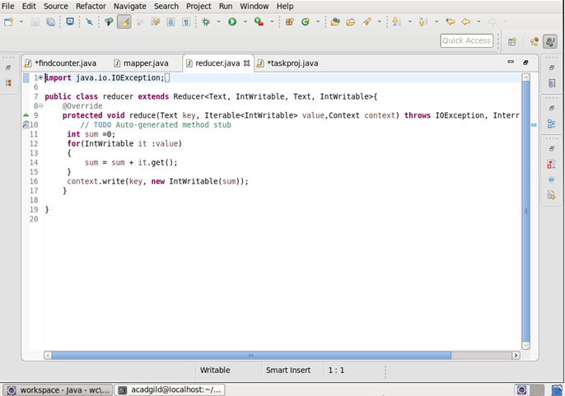

**Job Counter:-**

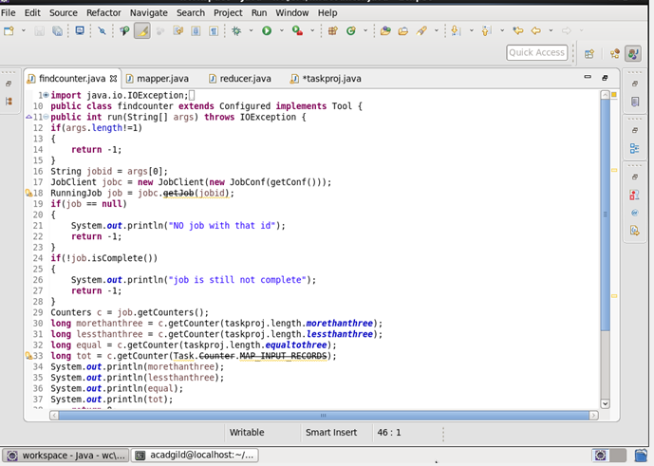

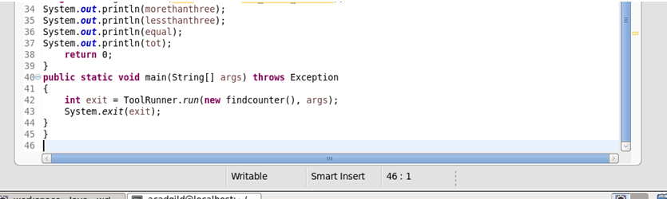

**Output:-**

